# Oral and Dental Problems among elderly

# Outlines:-

# 1

# 2

# 3

# 4

# 5

# 6

# 7

# 8

# 9

# ورقة الغلاف

# Anatomy and physiology of the oral cavity

The oral cavity (mouth) includes the lips, cheeks, palate (roof of the mouth), floor of the mouth and the part of the tongue in the mouth (oral tongue). A mucous membrane lines and protects the inside of the mouth. The structures in the oral cavity play an important role in speech, taste and the first steps of digestion.

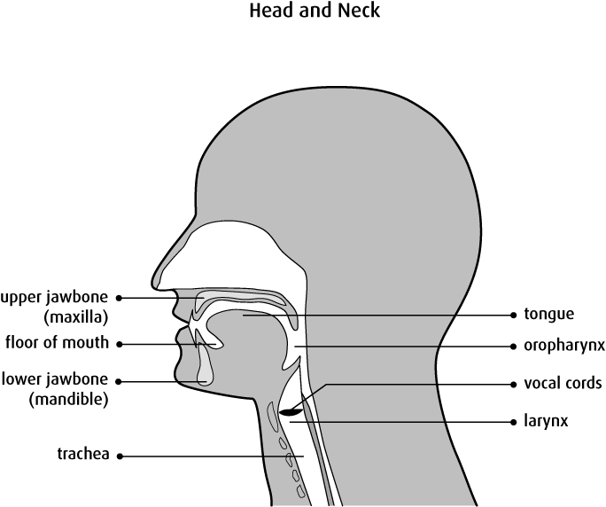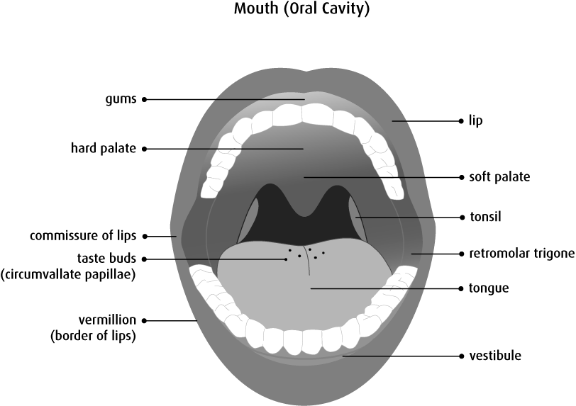

**Note:** The lining of the lips and cheeks (buccal mucosa) are not shown.

## Structure

The oral cavity begins at the border between the skin and the lips (vermillion border). The roof of the mouth is formed by the hard palate. The oral cavity leads into the oropharynx, which includes the soft palate, the back of the tongue and the tonsils. The inner surface of the cheeks forms the sides of the oral cavity. The lowest part of the oral cavity is the floor of the mouth, which is covered by the tongue.

The oral cavity can be divided into specific areas, including:

* lips
* labial mucosa (inner lining of the lips)
* commissure of lips (where the upper and lower lips meet at the corner of the mouth)
* vestibule (a space bounded by the teeth and gums on the inside and the mucosal surface of the lips and cheeks on the outside)
* oral tongue (the front two-thirds of the tongue)
* floor of the mouth
* buccal mucosa (the inner lining of cheeks)
* gingiva (gums)
* retromolar trigone (the area just behind the back molars in the lower jaw)
* hard palate (the bony part at the front of the roof of the mouth)
* teeth
* lower jaw (mandible)
* upper jaw (maxilla)

## Function

The function of the oral cavity and its structures is to begin the process of digestion. The oral cavity receives food, chews and mixes it with saliva and then begins the swallowing process. The taste buds on the tongue provide the different sensations of taste. The oral cavity plays an important role in speech. The mouth is also used for breathing, drinking, facial expressions and social interactions (such as kissing).

Adult teeth  
After 6 years, adult teeth (permanent teeth) will gradually begin to replace all of the milk teeth. This replacement events will last for about 7 years. This means that before you turn 12-14 years, you will have both milk and adult teeth all mixed up. This stage is called Mixed Dentition.

After 14 years, you should only have adult teeth, and about 28 in number. Your adult teeth will last for life so it is EXTREMELY important that you take good care of them, because if you loose them, new ones will NEVER come. Got it?

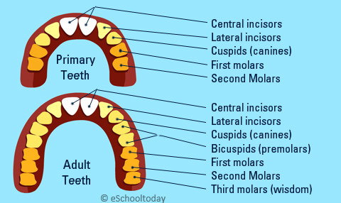

**Age- related changes in oral cavity**

1. ***Age related changes in soft tissue (Gum):-***

Because of normal processes of ageing, older adults have particular oral care needs. There is progressive loss of soft tissue attachments which results in root exposure and loosening of the teeth and there is increasing brittleness, making them more susceptible to damage **(Pandy et al., 2014).**

The gum tissue of the elderly individual gradually recedes from the tooth, with subsequent exposure of more of the tooth surface and root. The degree that gingival recession progresses is related to age, tooth movement, inflammatory changes resulting from disease, oral care habits, and heredity **(Michele and chin, 2013).**

1. ***Age related changes in teeth:-***

It is frequently reported that the teeth themselves undergo changes with age. Teeth differ from most other parts of the body in that the reparative or regenerative capacity of their constituent tissues is extremely limited. Also, the blood vessels and nerves become less active with age; as a result, the vitality of the average human tooth pulp lasts approximately 70 years **(Michele and chin, 2013).** Abrasion, attrition, and erosion of teeth usually increase with advancing age. The dental pulp becomes smaller because of secondary dentin and pulp stone formation, and sometimes root canals become totally sclerosed **(Pandy et al., 2014)**

1. ***Age related changes in oral mucosa:-***

The stereotypic effect of aging on the oral mucosa is that atrophic changes occur. Clinically, these changes involve the surface epithelium becoming thinner, drier, less elastic, less vascular, less firmly attached to the underlying connective tissue and bone, and more susceptible to injury from mild stresses. Other changes occur as well with reduction in connective tissue and subcutaneous fat and increased linkage of collagen molecules. Some symptoms have been associated with these alterations, including xerostomia (mouth dryness) and sensations of pain or burning on the tongue, palate, or oral mucosa **(Michele and chin, 2013).**

1. ***Age related changes in tongue:-***

As for the tongue, the clinical symptom called “smooth tongue” appears due to the disappearance of filiform papilla, and it is said that the threshold value for sensing a sweet taste lowers **(Japan Dental Association, 2015).** Tongue vascularity changes very little compared with that of other organs because there is little tendency in this tissue for atherosclerosis or obliteration of the capillaries. There is much controversy about whether aging is associated with atrophy of the papillae, increased formation of fissures, and decreasing sensitivity to gustatory stimuli in the tongue **(Michele and chin, 2013).**

1. ***Age related changes in salivary gland and saliva:-***

The diminished function of salivary gland is commonly associated with aging. The implications of disordered salivary gland maintenance of oral health. The presence of saliva protects the oral cavity the upper airway and digestive tract and facilitates numerous sensorimotor phenomena. The absence of saliva thus has many deleterious consequences to the host. With advancing age, there is an atrophy of acinar tissue, a proliferation of ductal elements and some degenerative changes in the major salivary glands. These alterations tend to occur linearly with increasing age. Minor salivary glands also undergo similar degenerative changes with advancing age. Thus, there is a normal, uniform decrease in the acinar content of salivary gland tissue accompanying the aging process **(Abdul-Razak et al., 2014).**

# Common oral and dental problems among elderly

# The most important oral health problems that have been recorded in dental literature for older population include tooth loss, dental caries, periodontal diseases, xerostomia (dry mouth) and oral cancer. Edentulism influences social life, either causing aesthetic problems or affecting functional abilities, such as speaking, chewing and eating. Dental caries in older people is similar to that in people in their thirties. In addition, the accumulation of several risk factors, such as plaque or systemic diseases, acts synergistically in the onset of periodontal disease in seniors

#### 1.Gum disease

The first stage of [gum disease](http://www.mouthhealthy.org/en/az-topics/g/gum-disease) is called gingivitis, which is the only stage that is reversible. If not treated, gingivitis may lead to a more serious, destructive form of gum/periodontal disease called periodontitis. It is possible to have gum disease and have no warning signs. That is one reason why regular dental checkups and periodontal examinations are so important. Treatment methods depend upon the type of disease and how far the condition has progressed. Good oral hygiene at home is essential to help keep periodontal disease from becoming more serious or recurring. Brush twice a day, clean between your teeth daily, eat a balanced diet, and schedule regular dental visits for a lifetime of healthy smiles.

# *Gum disease risk factors*

***The main cause of periodontal (gum) disease is plaque, but other factors affect the health of your gums*.**

Age: Studies indicate that older people have the highest rates of periodontal disease. Data from the Centers for Disease Control and Prevention indicates that over 70% of Americans 65 and older have periodontitis.

Smoking/Tobacco Use: Tobacco users also are at increased risk for periodontal disease. Studies have shown that tobacco use may be one of the most significant risk factors in the development and progression of periodontal disease.

Genetics: Research has indicated that some people may be genetically susceptible to gum disease. Despite aggressive oral care habits, these people may be more likely to develop periodontal disease. Identifying these people with a genetic test before they even show signs of the disease and getting them into early intervention treatment may help them keep their teeth for a lifetime.

Stress:. Stress also is a risk factor for periodontal disease. Research demonstrates that stress can make it more difficult for the body to fight off infection, including periodontal diseases.

Medications: Some drugs, such as oral contraceptives, anti-depressants, and certain heart medicines, can affect your oral health. Just as you notify your pharmacist and other health care providers of all medicines you are taking and any changes in your overall health, you should also inform your dental care provider.

Clenching or Grinding Your Teeth: Clenching or grinding your teeth can put excess force on the supporting tissues of the teeth and could speed up the rate at which these periodontal tissues are destroyed***.***

## Other Systemic Diseases: Other systemic diseases that interfere with the body's inflammatory system may worsen the condition of the gums. These include cardiovascular disease, diabetes, and rheumatoid arthritis.

Poor Nutrition and Obesity:A diet low in important nutrients can compromise the body's immune system and make it harder for the body to fight off infection. Because periodontal disease begins as an infection, poor nutrition can worsen the condition of your gums. In addition, research has shown that obesity may increase the risk of periodontal disease

#### 2. Tooth decay and Missing Teeth

Older adults are at increased risk for root caries because of both increased gingival recession that exposes root surfaces and increased use of medications that produce xerostomia; approximately 50% of persons aged older than 75 years of age have root caries affecting at least one tooth

Did you know that the average adult between the ages of 20 and 64 has three or more decayed or missing teeth? If you are missing one or more teeth, there are plenty of reasons to correct the problem. For one thing, a large space between your teeth may affect how you speak or eat. Even if it’s not noticeable, a missing molar can affect how you chew. Remaining teeth may shift and in some cases, bone loss can occur around a missing tooth. With today’s advances, you don’t have to suffer from missing teeth.

## The top 10 causes of tooth decay include:

**Poor Oral Hygiene Practices:** Poor oral hygiene not only includes brushing your teeth regularly, but not flossing regularly, not brushing your tongue, and not using mouth wash. You should brush your teeth at least twice a day – morning and night, but it is ideal to brush after every meal. And remember to brush for at least two minutes. Set a little timer for yourself while you’re brushing to ensure that you brush your teeth for the full two minutes. Improper oral hygiene will ultimately lead to tooth decay. Tooth decay due to poor oral hygiene is avoidable.

**Deep Tooth Crevices and Enamel Issues:** Individuals with enamel issues and who have deep crevices in their teeth are highly-likely to have problems with tooth decay. This is because the deep crevices allow bacteria and plaque easy access to grow. Dental sealants are typically used to prevent tooth decay in patients with deep tooth crevices. A dental sealant is only safe for uninfected teeth for the prevention of tooth decay.

**Improper Nutrition:** Avoiding foods that are high in sugar, high in carbohydrates and high in acid is the best way to avoid tooth decay due to improper nutrition. Eating a healthy diet, which includes healthy foods and the avoidance of sugary acidic drinks is the way to go.

**Sugary Foods:** Sugary foods are the best friends of the bacteria in your mouth. The bacteria in your mouth literally feed off of sugary foods, and then begin to coat your teeth in damaging acid. This can all happen in a matter of seconds and can occur several times over the course of just one meal, which is why it’s recommended to brush your teeth after each meal to eliminate acid. When thinking of sugary foods, you more than likely think of “candy” and things like that, when in fact, there are many foods that contain “hidden sugars.” So be careful and always be on the lookout for hidden sugars. Remember, sugary drinks such as juice are just as damaging to your teeth as soda.

**Acidic Foods and Drinks:** When most people think of “acidic” they more than likely think of “soda,” when in fact many common foods which people consume on a daily basis contain acid. Shockingly, even foods such as fish and bread contain acid. Of course, [carbonated beverages](http://www.deltadentalins.com/oral_health/healthyfoods.html) such as soda, as well as fruit juice are all acidic agents which cause tooth decay. Unlike the way that bacteria feed off of sugary foods so they can coat the teeth in acid, acidic foods and drinks immediately begin to damage tooth enamel with their own acid.

**Dry Mouth Issues:** Due to the fact that saliva helps inhibit the growth of plaque, persons with dry mouth conditions will more than likely have dental issues which lead to tooth decay. Dry mouth may be caused by prescription medications, it may be genetic, or it may be caused by medical conditions such as Diabetes. A vigilant dentist will work closely with a patient to prevent tooth decay or further tooth decay due to dry mouth issues.

**Tooth Grinding**: Many people grind their teeth and do not even realize that they do this. Tooth grinding typically occurs when persons are asleep or when they’re under immense stress. Tooth grinding leads to tooth decay due to the fact that it strips away the outer layer of tooth enamel. Tooth grinding is preventable with the use of a “bite guard,” also known as a “night guard,” and with the reduction of stress.

**Genetics:** Often times, many people have issues with tooth decay thanks to genetics. Just as you inherit the color of your eyes and hair from your family, you also inherit deep tooth crevices and enamel issues, which lead to cavities.

**Age:** There are many reasons that cavities become more common with age, but some include common prescription medications which cause dry mouth, the recession of gums with age, and improper oral hygiene finally catching up with age.

**Avoiding the Dentist:** Lastly, avoiding a visit to the dentist is not good for your teeth and will ultimately lead to future tooth decay. If you’re afraid of the dentist, don’t be. The dentist is here to help you. Ideally, you should visit the dentist every six months for routine cleaning and an examination. During the examination at the dentist, your dentist will examine your mouth for any signs of tooth decay. If signs of tooth decay exist, your dentist will work quickly to treat the issues, as well as providing any preventive measures to avoid future tooth decay all together.

**Here are some options to replace a lost tooth or teeth. Talk to your dentist about which option is best for you:**

* [Bridges](http://www.mouthhealthy.org/en/az-topics/b/bridges). Anchored to your adjacent teeth, these can be removable or fixed, depending on your mouth, your dentist’s recommendation and your needs.
* [Dentures.](http://www.mouthhealthy.org/en/az-topics/d/dentures) An option if you’ve lost all or most of your teeth.
* [Implants](http://www.mouthhealthy.org/en/az-topics/i/implants). Most similar to a natural tooth.

#### 3. Sensitivity

[sensitive teeth](http://www.mouthhealthy.org/en/az-topics/s/sensitive-teeth). Is a common dental problem and wince feeling when eating hot or cold foods .Sensitivity in teeth can happen for several reasons, including?

* [tooth decay](http://www.mouthhealthy.org/en/az-topics/d/decay) ([cavities](http://www.mouthhealthy.org/en/az-topics/c/cavities))
* fractured teeth
* worn fillings
* [gum disease](http://www.mouthhealthy.org/en/az-topics/g/gum-disease)
* worn tooth enamel
* exposed tooth root

Sensitive teeth can be treated. Your dentist may recommend desensitizing toothpaste or an alternative treatment based on the cause of your sensitivity. Proper oral hygiene is the key to preventing sensitive-tooth pain. Ask your dentist if you have any questions about your daily oral hygiene routine or concerns about tooth sensitivity.

#### 4. Dry mouth

Everyone’s mouth can be dry sometimes, but if you feel like your mouth is always dry, it may be time to seek treatment. Medications and certain health conditions can lead to [dry mouth](http://www.mouthhealthy.org/en/az-topics/d/dry-mouth). A dentist will check your teeth for signs of [decay](http://www.mouthhealthy.org/en/az-topics/d/decay) that can result from decreased salivary flow. A physician will test for any underlying disease or conditions that may be causing your dry mouth. Having a dry mouth is not itself serious but taking care of your teeth and gums and regular dental visits are important when living with dry mouth. Without the cleansing effects of [saliva](http://www.mouthhealthy.org/en/az-topics/s/saliva), tooth decay and other oral health problems become more common. Patients using oral inhalers for asthma often develop oral candidiasis, an oral fungal infection, and are encouraged to rinse their mouths with water after using the inhaler. Tell your dentist what medications you are taking and any other information about your health that may help identify the cause of your dry mouth.

#### 5. Oropharyngeal Cancer

Ororpharyngeal cancer can affect any area of the oropharyngeal cavity including the lips, gum tissue, check lining, tongue, jaw the hard or soft palate and throat. It often starts as a tiny, unnoticed white or red spot or sore or swelling anywhere in the mouth or throat.   
During your dental visit, your dentist can talk to you about your health history and examine these areas for signs of mouth and/or throat cancer. Regular visits to your dentist can improve the chances that any suspicious changes in your oral health will be caught early, at a time when cancer can be treated more easily.

**The symptoms of mouth or throat cancer can include:**

* sores that bleed easily or do not heal
* a thick or hard spot or lump
* a roughened or crusted area
* numbness, pain or tenderness
* a change in the way your teeth fit together when you bite down.

Make sure to tell your dentist about any problems you have when chewing, swallowing, speaking or moving your tongue or jaw. Regular dental check-ups, including an examination of the entire mouth, are essential in the early detection of cancerous and pre-cancerous conditions.***.***

**Signs and symptoms of oral and dental problems among elderly**.

1. [**Toothache**](http://www.mouthhealthy.org/en/az-topics/a/abscess)

If your mouth or jaw hurt, it could be from a toothache. Toothaches usually indicate a cavity but they can also signal gum disease. In some cases, a toothache is a sign of an abscess or impacted tooth. A toothache should be evaluated by a dentist right away to determine the cause of the problem and prevent the tooth from dying.

1. [**Sensitive Teeth**](http://www.mouthhealthy.org/en/az-topics/s/sensitive-teeth)

If your teeth hurt when you drink hot or cold beverages, you may have sensitive teeth. This can be the result of tooth decay, fractured teeth, worn fillings, gum disease, worn tooth enamel or an exposed tooth root due to gum recession. Treatment will depend on the source of sensitivity. If you’re concerned about the sensitivity of your teeth see your dentist for diagnosis and treatment options.

1. [**Bleeding or Sore Gums**](http://www.mouthhealthy.org/en/az-topics/b/bleeding-gums)

Bleeding or sore gums can be a sign of gingivitis, an early and reversible stage of gum disease, or simply the result of brushing too hard or starting a new flossing routine. If your gums bleed regularly, or enough to worry you, make an appointment with your dentist or physician, it could be a sign that something else is wrong.

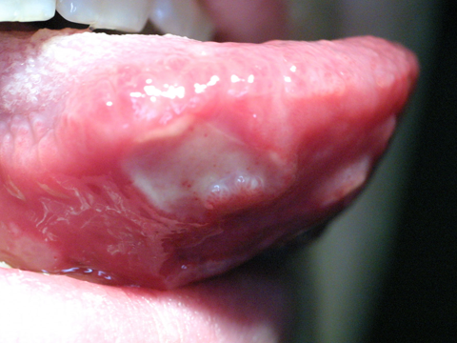

1. **Mouth Sores**

Types of mouth sores include canker sores, cold sores, leukoplakia and candidiasis. They vary in their severity and causes. Mouth sores could be the symptom of a disease or disorder; infection from bacteria, viruses or fungus or result from irritation caused by braces, dentures or the sharp edge of a broken tooth or filling. Your dentist should examine any mouth sore that lasts a week or longer.

1. [**Breath**](http://www.mouthhealthy.org/en/az-topics/b/bad-breath)

Bad breath can be caused by what you eat, not cleaning your mouth, dry mouth, smoking or other medical conditions. Persistent bad breath can also be one of the warning signs of gum disease. Brushing twice a day and flossing daily are essential to reducing bad breath and preventing gum disease. Brushing your tongue can help too. If you’re concerned about what’s causing your bad breath, see your dentist. They can determine the cause and treatment plan.

## 6[. Jaw Pain or Popping/Clicking in the Jaw](http://www.mouthhealthy.org/en/az-topics/j/jaw-pain)

Many things can cause these symptoms, which can make it difficult to diagnose. Possible causes include sinus problems, toothache, arthritis, injury, teeth grinding, gingivitis or problems with your jaw like TMJ. Your dentist will conduct a thorough exam, which may include X-rays, to determine the source of the pain.

## [Dry Mouth](http://www.mouthhealthy.org/en/az-topics/d/dry-mouth)

If you have dry mouth it may be the symptom of a medical disorder or a side effect of certain medications. Saliva is the mouth’s primary defense against tooth decay. It washes away food and other debris, neutralizes acids produced by bacteria in the mouth and provides disease-fighting substances throughout the mouth. Your dentist can recommend ways to restore moisture

## 8[. Oral Piercing Infection](http://www.mouthhealthy.org/en/az-topics/o/oral-piercings)

1. Oral piercings can create a wide range of problems for your health, oral and otherwise. Your mouth is home to huge amounts of bacteria, creating an ideal place for infection to start. If you have any signs of infection—swelling, pain, fever, chills, shaking or a red-streaked appearance around the site of the piercing—contact your dentist or physician immediately.
2. [**Cracked or Broken Teeth**](http://www.mouthhealthy.org/en/az-topics/d/dental-emergencies)
3. A cracked or broken tooth can happen for a variety of reasons—brittle teeth, teeth grinding, injury. The crack may be invisible to the naked eye and even X-ray, but they can be incredibly painful and create bigger problems if left untreated. If you experience pain when chewing see your dentist. They can diagnose the cause and develop a plan for treatment.

## [Stained or Discolored Teeth](http://www.mouthhealthy.org/en/az-topics/w/whitening)

Over time your teeth can become stained and change color. This is often the result of eating certain foods, such as coffee or tea, smoking, aging, genetics, injury, or certain medications. Whitening options can include over the counter or in office treatments. Check with your dentist about your options for stain removal

.

**Management of common dental problem**

Oral health plays a pivotal role in general health, especially in older people. Oral diseases may also affect the onset of systemic conditions such as diabetes mellitus, cardiovascular disease, stroke and hypertension. On the other hand, there is abundant evidence supporting the idea that the improvement of oral health results in controlling systemic diseases such as diabetes mellitus. Periodontal disease is characterized as a multi-factorial inflammatory disease, which may share the same risk factors with various systemic diseases. Not only periodontal disease, but also dental caries and oral cancer, may exhibit an interplay role. The process of growing old increases the risk of chronic conditions that may influence the prevalence of oral conditions in older people

1. Tooth Pain

Prevention :- • Brush at least twice a day, preferably after meals and snacks. • Floss at least once a day to prevent gum disease. • Visit your dentist regularly for oral examinations and a professional cleaning twice a year.

1. Missing teeth/tooth loss

Treatment :- • Dental Implant • Fixed Denture • Removable Partial Denture • Removable Complete Denture

1. Bleeding Gums • Gingivitis •

Treatment :- •Scaling •Proper Oral Hygiene habits •Warm water gargle/Mouth wash •Oral Gel

1. Bad Breath
2. Treatments •If you don't brush and floss teeth daily, food particles can remain in your mouth, promoting bacterial growth between teeth, around the gums, and on the tongue This causes bad breath. •Smoking or chewing tobacco-based products also can cause bad breath, stain teeth, reduce your ability to taste foods, and irritate your gums. •Systemic disorder like diabetes constipation etc. & consumption of onions and garlic's which leads to bad breath •Identify the cause •Scaling •Mouth Wash •Oral Gels
3. MobileTeethReasons Treatment :- •Extraction •Root Canal
4. Tooth Discoloration :-

Treatment :- •Bleaching •Scaling • Environment: Excessive fluoride from environmental sources, such as high fluoride levels in drinking water, or from excessive use of fluoride applications, rinses, toothpastes and oral fluoride supplements, can cause teeth discoloration.

Treatment :- •Filling •Root canal treatment •Cap

8Cold drinks are the biggest source of sugar that can damage your teeth. Treatment :- • Filling • Root Canal • Extraction •Fluoride Application

**Top of Form**

**Barriers of oral health among elderly**

### تستبدل بجزء عن recommendation of oral health among elderly

### Cognitive Limitations Affecting Dental Care and Self-Care

Patients with severe cognitive impairment, including dementia, are at increased risk for caries, periodontal disease, and oral infection because of decreased ability to engage in self-care.14 Education of the caregiver, as well as the patient, is an important part of the prevention and disease management phase of dental care.5, 14  
  
Communication during the dental appointment may be challenging when the older adult has cognitive impairments. It is recommended that the number of people, distractions, and noise in the operatory be minimized when providing care to a patient with dementia, although a trusted caregiver in the room may provide reassurance to the patient.23 Patients should be approached from the front at eye level and use of nonverbal communication, such as smiling and eye contact, is important.23 The dentist should begin the conversation by introducing himself or herself. Because a patient with cognitive limitations may become overloaded with information easily, instructions should be simple and sentences short, such as, “Please open your mouth.”23  
  
Because cognitive impairment or dementia can affect a patient’s ability to follow instructions following oral surgery, it is recommended that practitioners ensure local hemostasis (i.e., sutures, local hemostatics, socket preservation techniques) prior to dismissal from the dental practice.14  
  
Dentate patients with cognitive limitations should be encouraged to brush their teeth two or more times daily; use of an electric or battery-operated toothbrush should be considered.14 The same oral care routine should be followed consistently, as possible.14 In patients with removable prosthetic devices, the device(s) should be removed, inspected, and cleaned before bed and returned to the mouth in the morning.14

### Physical and Sensory Limitations Affecting Dental Care and Self-Care

Patients with Hearing Loss:  Dental care providers should speak slowly, clearly, and loudly when talking with older patients to enhance hearing and understanding.23 It is important to make sure that speaking loudly and slowly does not introduce a patronizing or condescending tone of voice.23 Yellowitz in The ADA Practical Guide to Patients with Medical Conditions14 advises the following in communicating with patients with hearing loss and/or hearing aids:

* + In patients who read lips, face the patient while speaking, speak clearly and naturally; and make sure your lips are visible (remove mask). Be at the same level as the patient.
  + Gain the patient’s attention with a light touch or signal before beginning to speak. Be sure the patient is looking at you when you are speaking and avoid technical terms. Use written instructions and facial expressions.
  + Inform the patient before starting to use dental equipment or when equipment is changed, resulting in an altered experience, e.g., vibrations from a low-speed versus a high-speed handpiece.
  + In patients with hearing aids, minimize background noise when speaking. Avoid sudden noises and putting your hands close to the hearing aid(s). Patients may want to adjust or turn off the hearing aid(s) during treatment.
  + Written and illustrated materials and websites can be used to help explain dental information, procedures, and postoperative instructions

Patients with Visual Loss:  Age-related visual impairment, such as cataracts, glaucoma or presbyopia, can diminish a person’s ability to process nonverbal conversational cues that frequently are communicated visually.23 Ensure the patient can clearly see demonstrations and read written materials, including appointment cards and instructions.14 The following tools and strategies14 can assist visually impaired older adults in the dental office:

* + Large-print magazines in the waiting room
  + Good lighting throughout the office; add spot/task lighting in areas used for completing forms
  + Large print on prescription bottles
  + Install blinds or shades to reduce glare
  + Use contrasting colors on door handles, towel racks, and stair markers

Patients with Physical Limitations/Loss of Mobility:  Osteoarthritis or rheumatoid arthritis in the hand, fingers, elbow, shoulder, and/or neck can affect a person’s ability to maintain good quality oral health self-care.14 Modification of manual toothbrush handles (e.g., with Velcro® straps or attaching a bicycle handlebar grip) or use of an electronic toothbrush with a wide, grippable handle can help accommodate for lost mobility.14 Floss holders or interdental cleaners/brushes can aid in cleaning between teeth.14 Increasing the frequency of dental cleanings and examinations can help promote optimal maintenance of oral hygiene.14

**Oral Health Care Procedure**

Oral hygiene includes the prevention of plaque-related disease, the destruction of plaque through the mechanical action of tooth brushing and flossing or use of other oral hygiene aides **(WHO, 2014b).** The elderly person should be helped to develop the ability to brush effectively and thoroughly. Those who have diminished manual dexterity may benefit from the use of traditional mechanical toothbrushes, rotary electric toothbrushes, or manual brushes that have been adapted or customized for each person

*Brushing

Clean the tooth surfaces by toothbrushing

Toothbrushing can remove dental plaque on tooth surfaces. We should brush our teeth in the morning and before bed at night every day..

Place the toothbrush at an angle towards the gingival margin (gum margin)

The toothbrush head should be placed with the tips of the bristles tilted at an angle towards the gingival sulcus which is located at the gingival margin, and where plaque tends to accumulate.



(Dental plaque accumulates in the sulcus)

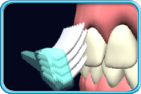

Place the tips of the bristles tilted at an angle towards the gingival margin)

Brush the teeth systematically**

1-Firstly, brush the outer surfaces of the lower teeth. The toothbrush head should be placed with the tips of the bristles tilted at an angle towards the gingival margin. Gently move the toothbrush in small scrubbing motions, working on two to three teeth at one time. 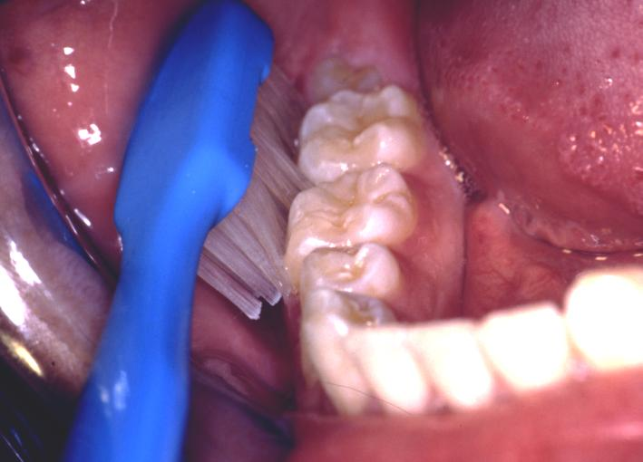

2-Then brush the inner surfaces of teeth in the same way as brushing the outer surfaces

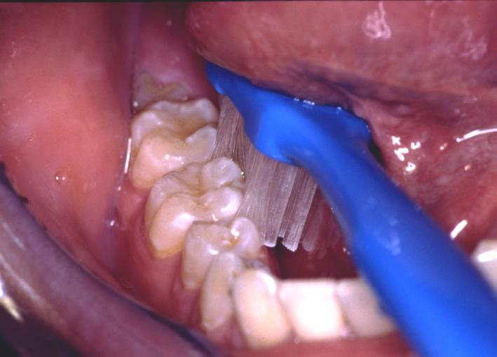

. 3-When we brush the inner surfaces of front teeth, we should hold the toothbrush upright using gentle motion brushing from the gingival margin towards the crowns of the teeth

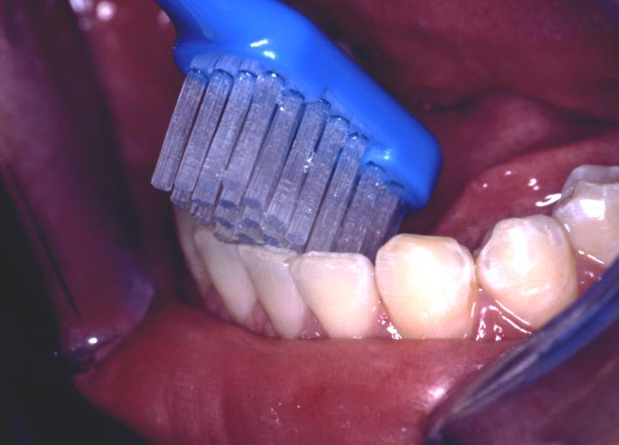.

4-Then brush the chewing surfaces of the teeth with the toothbrush moving backward and forward

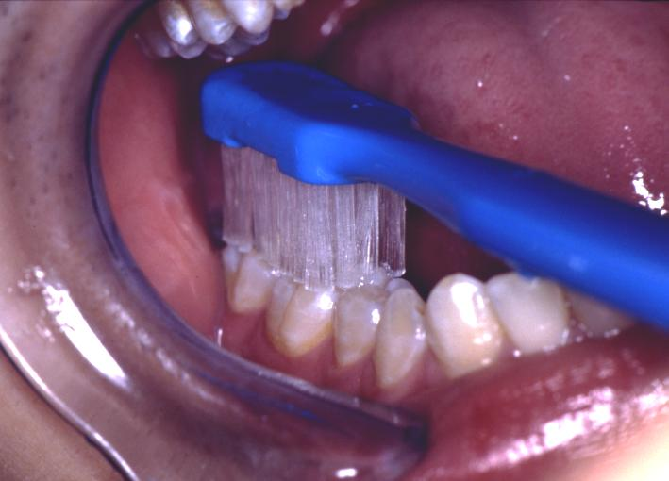.

5-Finally, brush the outer surfaces, inner surfaces and the chewing surfaces of the upper teeth in the same way as the lower one

*flossing *

Toothbrushing cannot clean the adjacent surfaces of teeth. If we want to remove the plaque accumulated on the adjacent tooth surfaces, we must use dental floss or interdental brush daily. Parents or caregivers can assist children or people in need to clean adjacent tooth surfaces by using a floss holder

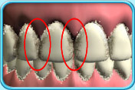

Flossing technique

1-Use a piece of dental floss which is approximately 20-25 cm long. Tie both ends to make a loop. Use the thumbs and the forefingers of both hands to hold the floss, leaving about 2 cm of floss in between



2-Use a sawing motion to slide the floss into the interdental space

3-Wrap around one tooth making a "C" shape and gently pull down to the deepest part of the gingival sulcus, and then slide it up and down against the tooth. Then wrap around the adjacent tooth and repeat the up and down motions



Clean all the other adjacent tooth surfaces in the same way

Points to note :

Please use a new part of floss every time as the used floss was contaminated with bacteria already

Method of using floss holder

. 1. Move the floss holder left and right and slowly slide the floss towards the gingival margin. Pull the floss tightly against one of the adjacent tooth surfaces



2. Start from the deepest part of the gingival sulcus, gently slide the floss up and down to clean the adjacent tooth surface.

3.

Pull the floss tightly against the other adjacent tooth surface.



4. Use the same technique, starting from the deepest part of the gingival sulcus, gently slide the floss up and down to clean the other adjacent tooth surface.

Clean all the other adjacent tooth surfaces in the same way.



Cleaning a removable denture

Dental plaque forms on the surface of a denture. In order to maintain the hygiene of the mouth and denture, the denture should be taken out for cleaning every night

Denture cleaning

First, fill the washing basin with some water to prevent accidental drop and fracture of the denture. Apply some detergent onto the toothbrush. Then clean every surface of the denture.



Before bedtime, immerse the cleaned denture into a cup of water overnight

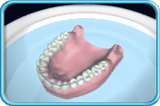

**Apropriate diet for oral healthy among elderly**

A balanced diet with adequate nutrients is essential for oral

health and in turn, oral health enhances nutritional well

being. Nutrition deserves special attention for older people

The guidelines recommend eating a variety of nutritious foods from each of the four major food groups each day, for older people to stay healthy.

The four major food groups are:

• Vegetables and fruits;

• Breads and cereals, preferably wholegrain;

• Milk and milk products, preferably reduced or low-fat options;

• Lean meat, poultry, seafood, eggs, nuts, seeds or legumes.

Nutrition tips for healthy teeth

• Encourage the person in your care to reduce the frequency and amount of sugar

consumption from foods and drinks by

o choosing foods that are low in sugar

o avoiding snacking on sugary, sticky foods between meals

• For those with dry mouth, encourage frequent sipping of non-sugared, low acidic

drinks such as water

• Advise the person to avoid frequent sipping of fruit juices, cordial or sugary drinks

• The intake of sugar-containing medications should be limited. Ask the doctor for

alternatives for the person in your care.

Nutrition tips for denture wearers

• Encourage denture wearers to use their knife and fork as their “teeth” to cut up

food into smaller portions

• Prepare chopped up vegetables or mashed vegetables for them. Avoid giving them

stringy foods

• Moisten difficult-to-chew foods with gravies and sauces, butter or margarine

• Provide small bite-sized portions of fruit.

reference

1. [Federal Interagency Forum on Aging-Related Statistics. Older Americans 2012: Key indicators of well-being](http://www.agingstats.gov/main_site/data/2012_documents/docs/entirechartbook.pdf)  Accessed October 30, 2015.  
  
2. Public health and aging: retention of natural teeth among older adults--United States, 2002. MMWR Morb Mortal Wkly Rep 2003;52(50):1226-9.  
  
3. [National Institute of Dental and Craniofacial Research. Dental caries (tooth decay) in seniors (age 65 and over). National Institutes of Health](http://www.nidcr.nih.gov/DataStatistics/FindDataByTopic/DentalCaries/DentalCariesSeniors65older.htm)  Accessed October 30, 2015.  
  
4. Eke PI, Dye BA, Wei L, et al. Update on Prevalence of Periodontitis in Adults in the United States: NHANES 2009 to 2012. J Periodontol 2015;86(5):611-22.  
  
5. Yellowitz JA, Schneiderman MT. Elder's oral health crisis. J Evid Based Dent Pract 2014;14 Suppl:191-200.  
  
6. Razak PA, Richard KM, Thankachan RP, et al. Geriatric oral health: a review article. J Int Oral Health 2014;6(6):110-6.  
  
7. Preston AJ. Dental management of the elderly patient. Dent Update 2012;39(2):141-3.  
  
8. Stein P, Aalboe J. Dental care in the frail older adult:  special considerations and recommendations. J Calif Dent Assoc 2015;43(7):363-8.  
  
9. [Administration on Aging (AOA). Health and health care. U.S. Department of Health and Human Services Administration for Community Living](http://www.aoa.acl.gov/Aging_Statistics/Profile/2014/14.aspx)  Accessed October 30, 2015.  
  
10. [World Health Organization. Ageing and health (Fact Sheet No. 404).  September 2015](http://www.who.int/mediacentre/factsheets/fs404/en/)  Accessed October 30, 2015.  
  
11. [World Health Organization. World report on ageing and health.  September 2015](http://apps.who.int/iris/bitstream/10665/186463/1/9789240694811_eng.pdf?ua=1)  Accessed November 10, 2015.  
  
12. Dodds C. Physiology of ageing. Anaesthesia & Intensive Care Medicine;7(12):456-58.  
  
13. Ouanounou A, Haas DA. Pharmacotherapy for the elderly dental patient. J Can Dent Assoc 2015;80:f18.  
  
14. Yellowitz JA. Geriatric health and functional issues. In: Patton LL, Glick M, editors. The ADA Practical Guide to Patients with Medical Conditions. 2nd ed. Hoboken, NJ: John Wiley & Sons, Inc.; 2016. p. 405-22.  
  
15. Kantor ED, Rehm CD, Haas JS, Chan AT, Giovannucci EL. Trends in prescription drug use among adults in the United States from 1999-2012. JAMA 2015;314(17):1818-31.  
  
16. Fitzgerald J, Epstein JB, Donaldson M, et al. Outpatient medication use and implications for dental care: guidance for contemporary dental practice. J Can Dent Assoc 2015;81:f10.  
  
17. Radler DR. Dietary supplements: clinical implications for dentistry. J Am Dent Assoc 2008;139(4):451-5.  
  
18. Bowie MW, Slattum PW. Pharmacodynamics in older adults: a review. Am J Geriatr Pharmacother 2007;5(3):263-303.  
  
19. American Geriatrics Society 2015 Updated Beers Criteria for Potentially Inappropriate Medication Use in Older Adults. J Am Geriatr Soc 2015.  
  
20. Jablonski RY, Barber MW. Restorative dentistry for the older patient cohort. Br Dent J 2015;218(6):337-42.  
  
21. U.S. Department of Health and Human Services. Oral Health in America: A Report of the Surgeon General. Rockville, MD: U.S. Department of Health and Human Services, National Institute of Dental and Craniofacial Research, National Institutes of Health; 2000.  
  
22. Gregory D, Hyde S. Root caries in older adults. J Calif Dent Assoc 2015;43(8):439-45.  
  
23. Stein PS, Aalboe JA, Savage MW, Scott AM. Strategies for communicating with older dental patients. J Am Dent Assoc 2014;145(2):1